Project Design Phase-II
Technology Stack (Architecture & Stack)

Date | 29 SEPTEMBER 2026
Team ID | SWITID-2026-3914
Project Name | Implement Client Script & UI Policy (Incident)
Maximum Marks | 4 Marks

Technical Architecture:
The Deliverable shall include the architectural diagram as below and the information as per the table1 & table 2
Example: Order processing during pandemics for offline mode
Reference: https://developer.ibm.com/patterns/ai-powered-backend-system-for-order-processing-during-pandemics/

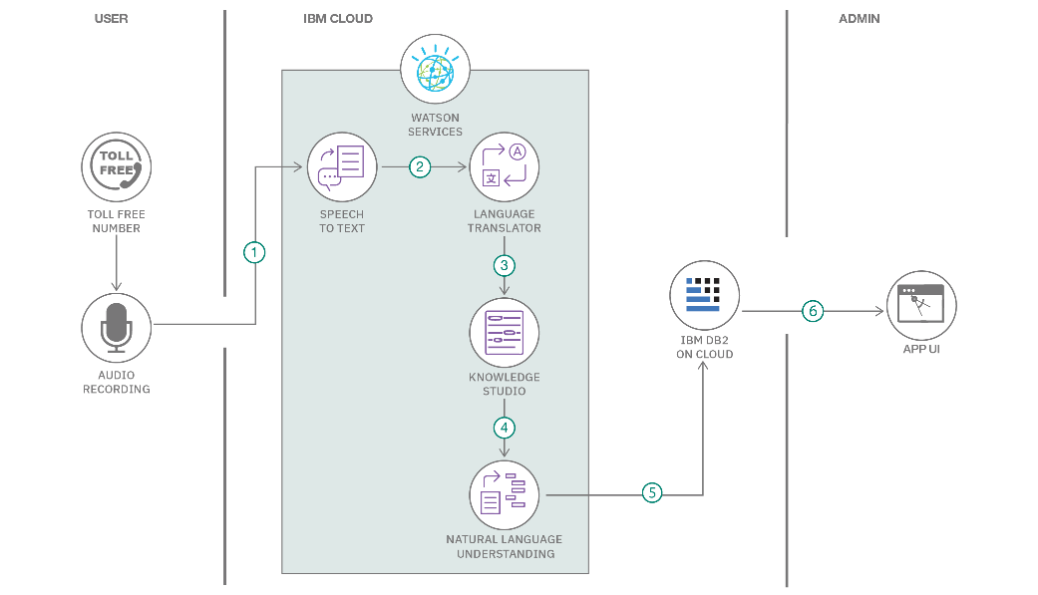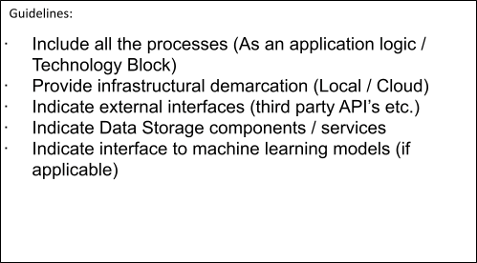

Table-1

:

Components

&

Technologies:

S.No

Component

Description

Technology

1.

User

Interface

How

user

interacts

with

application

e.g.

Web

UI,

Mobile

App,

Chatbot

etc.

HTML,

CSS,

JavaScript

/

Angular

Js

/

React

Js

etc.

2. | Application Logic-1 | Logic for a process in the application | Java / Python
3. | Application Logic-2 | Logic for a process in the application | IBM Watson STT service
4. | Application Logic-3 | Logic for a process in the application | IBM Watson Assistant
5. | Database | Data Type, Configurations etc. | MySQL, NoSQL, etc.
6. | Cloud Database | Database Service on Cloud | IBM DB2, IBM Cloudant etc.
7. | File Storage | File storage requirements | IBM Block Storage or Other Storage Service or Local Filesystem
8. | External API-1 | Purpose of External API used in the application | IBM Weather API, etc.
9. | External API-2 | Purpose of External API used in the application | Aadhar API, etc.
10. | Machine Learning Model | Purpose of Machine Learning Model | Object Recognition Model, etc.
11. | Infrastructure (Server / Cloud) | Application Deployment on Local System / Cloud Local Server Configuration:  Cloud Server Configuration : | Local, Cloud Foundry, Kubernetes, etc.
S.No | Characteristics | Description | Technology
1. | Open-Source Frameworks | List the open-source frameworks used | Technology of Opensource framework
2. | Security Implementations | List all the security / access controls implemented, use of firewalls etc. | e.g. SHA-256, Encryptions, IAM Controls, OWASP etc.
3. | Scalable Architecture | Justify the scalability of architecture (3 – tier, Micro-services) | Technology used
4. | Availability | Justify the availability of application (e.g. use of load balancers, distributed servers etc.) | Technology used

Table-2: Application Characteristics:
S.No | Characteristics | Description | Technology
5. | Performance | Design consideration for the performance of the application (number of requests per sec, use of Cache, use of CDN’s) etc. | Technology used

References:
https://c4model.com/ https://developer.ibm.com/patterns/online-order-processing-system-during-pandemic/ https://www.ibm.com/cloud/architecture https://aws.amazon.com/architecture https://medium.com/the-internal-startup/how-to-draw-useful-technical-architecture-diagrams-2d20c9fda90d

